551 277 01
PD 3950 USB to P-NET Interface  General information  The PD 3950 USB to P-NET Interface module provides an interface between the P-NET Fieldbus and a standard PC running VIGO The Fieldbus Management System version 5.7 or higher.  Using the PD 3950, any standard desktop, laptop or single board PC with a USB port, may be used as a node in a P-NET installation, in applications such as process and factory automation, machine control, building automation, data acquisition etc. | 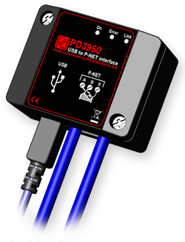

Specific Features
• P-NET Fieldbus communication interface.
• P-NET RS485, multi-master P-NET interface.
• Galvanically isolated P-NET communication port.
• Manual baudrate selection 9600, 76800 Baud.
• Can be connected to any standard USB port or USB HUB.
• Powered by the USB port via the USB cable.
• Supports firmware upgrade via USB.
• Channel for holding application licences.
• Compact designed, suitable for wall mounting, mounting underneath desk etc.

PD 3950 Block Schematic
The following block diagram shows the internal structure of a PD 3950 USB to P-NET Interface:
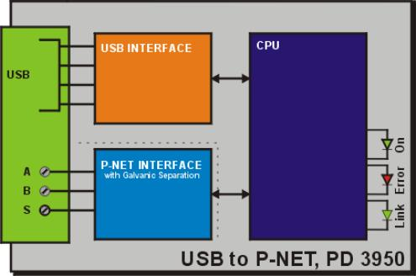

Channel Structure
The PD 3950 consists of 3 channels as shown in the table.
Channel No. | Channel name | Channel description
0 | Service | Service channel
1 | LicenceCh | Channel for holding application licences
2 | USBCh | USB channel

Electrical Specifications
Power consumption | Max. 246 mA
Temperature
Operating temperature | -25 °C - 70 °C
Storage temperature | -40 °C - 85 °C
Humidity
Relative humidity: | Max. 95%
EMC
EN 61000-6-2, EN 61000-6-3

Mechanical Details
The PD 3950 USB Interface is housed in a black plastic case.
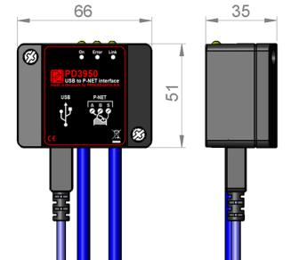
Dimensions | (WxHxD) | 66 x 51 x 35 mm
Case material |  | Polycarbonate
Front foil |  | ABS
Back plate |  | Black anodized aluminum
Weight |  | 75 grams

USB Cable
PROCES-DATA recommends that only the provided USB cable is used together with the PD 3950 USB interface.

